Jahangirnagar University
Institute of Information Technology
Savar, Dhaka-1342

Lab report - 01
Connecting End Devices (PCs) Using Hub and Switch

Course: Computer Networks Lab
Course Code: ICT-3104

Submitted To
Jesmin Akhter, PhD
Professor, Institute of Information Technology
Submitted By
Md. Shaon Khan
ID: 1984 Batch: 52 Session: 2022–2023

Date of Submission
7 May 2026
Lab -1: Connecting End Devices (PCs) Using Hub and Switch

Objective:
To understand how end devices (PCs) communicate in a network using a hub and a switch, and to observe the differences in data transmission behavior between a hub-based and a switch-based network.

Apparatus:

- Cisco Packet Tracer
- 1 Hub
- 1 Switch
- 8 End Devices (PCs or Laptops)
- Copper Straight-Through Ethernet Cable

Network diagram:

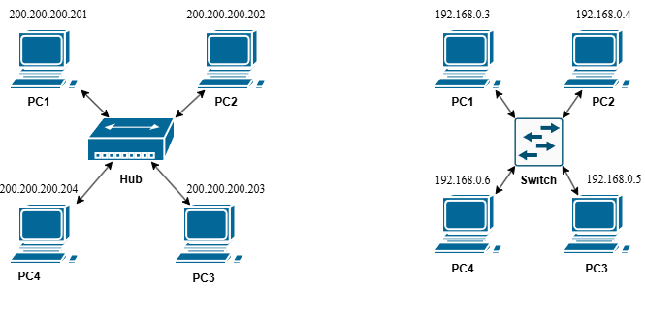

Procedure:

- Open Cisco Packet Tracer and place 1 hub, 1 switch, and 8 PCs on the workspace.

- Connect PC1 through PC4 to the hub using copper straight-through ethernet cables. Connect PC5 through PC8 to the switch in the same way.

- Assign static IP addresses to all PCs as follows:

Hub-connected PCs:
Device | IP Address
PC1 | 200.200.200.201
PC2 | 200.200.200.202
PC3 | 200.200.200.203
PC4 | 200.200.200.204

Switch-connected PCs:
Device | IP Address
PC1 | 192.168.0.3
PC2 | 192.168.0.4
PC3 | 192.168.0.5
PC4 | 192.168.0.6

Since all PCs within each group belong to the same network, no default gateway is required.

- To assign an IP address, click on a PC, go to Desktop → IP Configuration, select Static, and enter the IP address and subnet mask (255.255.255.0).

- Test connectivity by opening the Command Prompt on any PC and running the ping command toward another PC in the same group. For example:

ping 200.200.200.202

- Observe the behavior: on the hub network, all PCs receive the data packet (broadcast behavior), while on the switch network, data is sent only to the specific destination PC (unicast behavior).

Output:
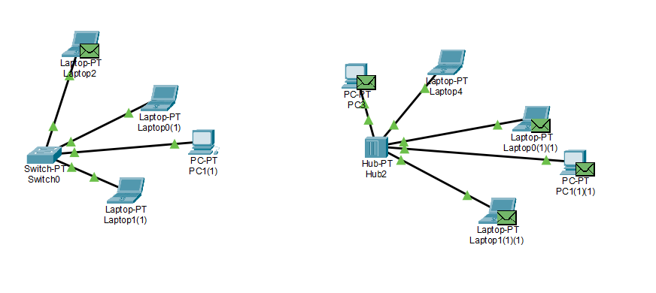

Jahangirnagar University
Institute of Information Technology
Savar, Dhaka-1342

Lab report - 02
LAN Connection Between 2 PCs Using Twisted Pair Cable and Router

Course: Computer Networks Lab
Course Code: ICT-3104

Submitted To
Jesmin Akhter, PhD
Professor, Institute of Information Technology
Submitted By
Md. Shaon Khan
ID: 1984 Batch: 52 Session: 2022–2023

Date of Submission
7 May 2026

Lab – 02: LAN Connection Between 2 PCs Using Twisted Pair Cable (RJ-45) and Router
Objective:
To establish a Local Area Network (LAN) between two personal computers (PCs) using UTP Cat5e twisted pair cables terminated with RJ-45 connectors and connected through a router, and to understand the wire serial order for Straight-Through, Crossover, and Rollover cables.
Apparatus:
- 2 Personal Computers (PCs) with Network Interface Cards (NIC)
- 1 Router (e.g., Cisco 2811 or equivalent)
- UTP Cat5e Cables (Straight-Through, Crossover, and Rollover)
- RJ-45 (8P8C) Connectors — 2 per cable (one at each end)
- RJ-45 Crimping Tool and Cable Tester
- Cisco Packet Tracer (simulation) or physical lab hardware

Network Diagram:
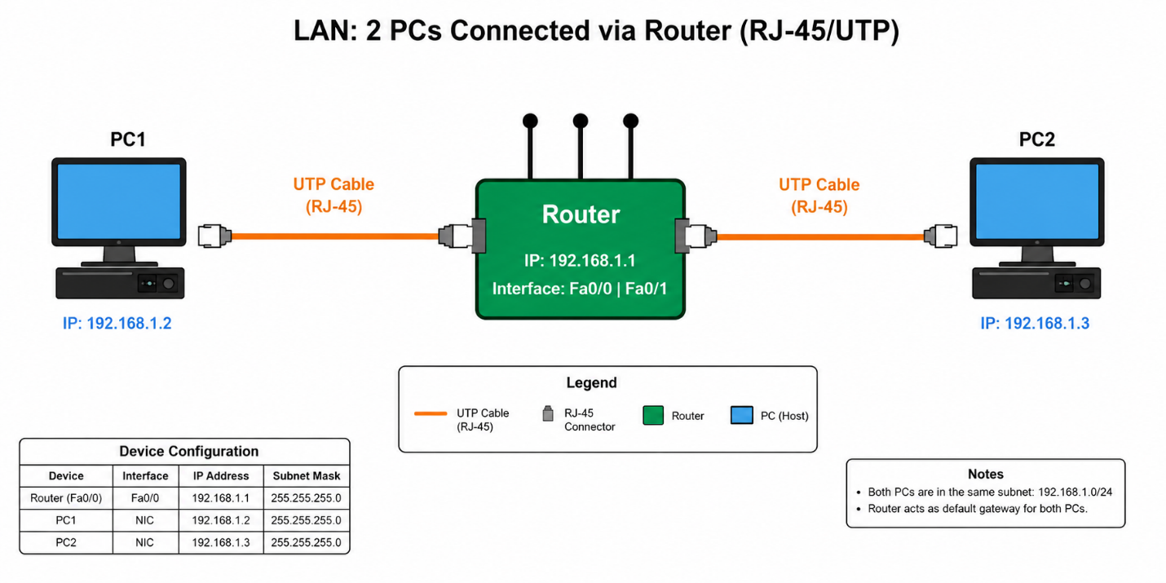
Figure 1: PC1 and PC2 connected to Router via UTP cables with RJ-45 connectors

RJ-45 Connector Overview:
RJ-45 (8P8C) is the standard modular connector used to terminate UTP Ethernet cables. It has 8 pins, and the serial order (sequence) in which the 8 wires are inserted into the connector determines the cable type Straight-Through, Crossover, or Rollover.
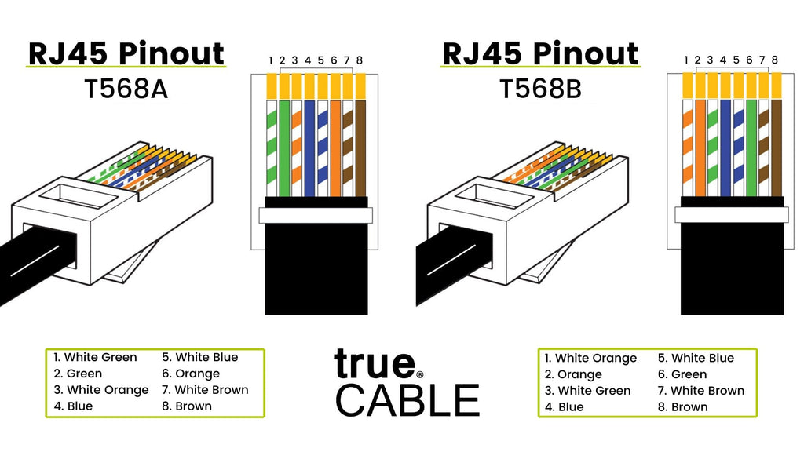
Figure 2: RJ-45 (8P8C) connector — pin layout and T568B wiring standard
Wire Serial Order (Cable Types):
The serial order of the 8 wires inside an RJ-45 connector defines the cable type and its use case. There are three standard cable types used in networking:
1. Straight-Through Cable (T568B - T568B)
Both ends follow the same T568B pin order. Used to connect UNLIKE devices such as PC to Router or PC to Switch.
End A (T568B) |  | End B (T568B)
Pin | Wire Color / Signal | Pin | Wire Color / Signal
1 | White / Orange (TX+) | 1 | White / Orange (TX+)
2 | Orange (TX−) | 2 | Orange (TX−)
3 | White / Green (RX+) | 3 | White / Green (RX+)
4 | Blue | 4 | Blue
5 | White / Blue | 5 | White / Blue
6 | Green (RX−) | 6 | Green (RX−)
7 | White / Brown | 7 | White / Brown
8 | Brown | 8 | Brown

2. Crossover Cable (T568B - T568A)
End A follows T568B and End B follows T568A. The TX pins of one end connect to the RX pins of the other, allowing two like devices to communicate directly without a switch or router.

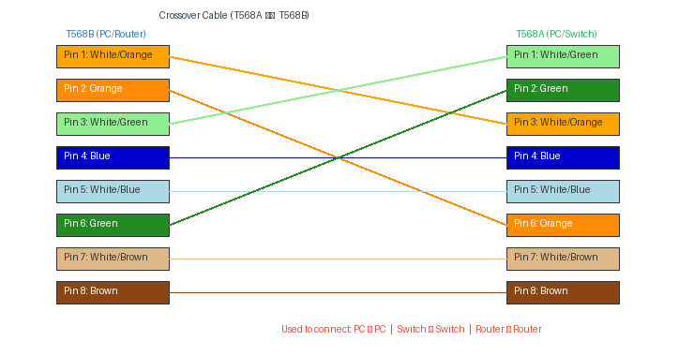
Figure 3: Crossover Cable - wire serial order showing TX/RX pin swap between End A and End B

End A (T568B) |  | End B (T568A)
Pin | Wire Color / Signal | Pin | Wire Color / Signal
1 | White / Orange (TX+) | 3 | White / Green (RX+)
2 | Orange (TX−) | 6 | Green (RX−)
3 | White / Green (RX+) | 1 | White / Orange (TX+)
4 | Blue | 4 | Blue
5 | White / Blue | 5 | White / Blue
6 | Green (RX−) | 2 | Orange (TX−)
7 | White / Brown | 7 | White / Brown
8 | Brown | 8 | Brown

3. Rollover Cable (Console Cable)
End B is a complete mirror/reversal of End A - Pin 1 connects to Pin 8, Pin 2 to Pin 7, and so on. Also called a Cisco console cable, it is used to access the CLI of routers and switches via the console port using a terminal program (e.g., PuTTY).
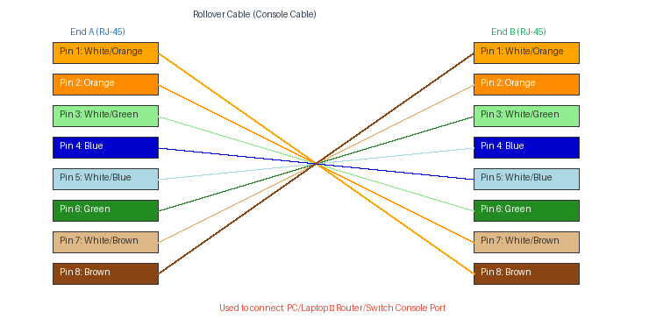
Figure 4: Rollover Cable - wire serial order showing full pin reversal between End A and End B

End A (RJ-45) |  | End B (RJ-45) — Reversed
Pin | Wire Color | Pin | Wire Color
1 | White / Orange | 8 | Brown
2 | Orange | 7 | White / Brown
3 | White / Green | 6 | Green
4 | Blue | 5 | White / Blue
5 | White / Blue | 4 | Blue
6 | Green | 3 | White / Green
7 | White / Brown | 2 | Orange
8 | Brown | 1 | White / Orange

IP Address Configuration:

Device | IP Address | Subnet Mask | Default Gateway
PC1 | 192.168.1.2 | 255.255.255.0 | 192.168.1.1
PC2 | 192.168.1.3 | 255.255.255.0 | 192.168.1.1
Router (Fa0/0) | 192.168.1.1 | 255.255.255.0 | N/A
Router (Fa0/1) | 192.168.1.1 | 255.255.255.0 | N/A

Procedure:
- Open Cisco Packet Tracer and place 1 Router and 2 PCs on the workspace.
- Prepare two UTP Cat5e straight-through cables, each terminated at both ends with RJ-45 connectors following the T568B serial order.
- Connect PC1 to the Fa0/0 port of the Router using Cable 1 (Straight-Through).
- Connect PC2 to the Fa0/1 port of the Router using Cable 2 (Straight-Through).
- Assign static IP to PC1: IP 192.168.1.2, Mask 255.255.255.0, Gateway 192.168.1.1.
- Assign static IP to PC2: IP 192.168.1.3, Mask 255.255.255.0, Gateway 192.168.1.1.
- Configure the Router interfaces via CLI (see commands below).
- Verify RJ-45 port link lights turn green on all devices.
- Open Command Prompt on PC1 and run: ping 192.168.1.3 to verify connectivity.

Router Configuration Commands (CLI):
Router> enable
Router# configure terminal
Router(config)# interface FastEthernet0/0
Router(config-if)# ip address 192.168.1.1 255.255.255.0
Router(config-if)# no shutdown
Router(config-if)# exit
Router(config)# interface FastEthernet0/1
Router(config-if)# ip address 192.168.1.1 255.255.255.0
Router(config-if)# no shutdown
Router(config-if)# end

Output:
The ping from PC1 to PC2 (192.168.1.3) returned 4 successful reply packets with 0% packet loss, confirming proper LAN connectivity through the router via straight-through RJ-45 cables.

Conclusion:
This lab demonstrated the practical importance of wire serial order in RJ-45 terminated UTP cables. A Straight-Through cable (T568B–T568B) connects unlike devices such as PC to Router. A Crossover cable (T568B–T568A) connects like devices directly by swapping TX and RX pairs. A Rollover (console) cable fully reverses all 8 pins and is used for device management via the console port. Correct wiring sequence is critical - an incorrect pin order will result in no connectivity regardless of IP configuration.

Jahangirnagar University
Institute of Information Technology
Savar, Dhaka-1342

Lab report - 03
Connecting End Devices (PCs) Using a Router

Course: Computer Networks Lab
Course Code: ICT-3104

Submitted To
Jesmin Akhter, PhD
Professor, Institute of Information Technology
Submitted By
Md. Shaon Khan
ID: 1984 Batch: 52 Session: 2022–2023

Date of Submission
7 May 2026
Lab -3: Connecting End Devices (PCs) Using a Router

Objective:
To study the role of a router in connecting different networks by configuring end devices (PCs) on separate networks, and to observe how data is transmitted and routed between these networks through proper IP configuration and connectivity testing.

Apparatus:
- Cisco Packet Tracer
- Switches
- 6 End Devices (PCs or Laptops)
- 1 Router
- Copper Straight-Through Ethernet Cable

Network diagram:

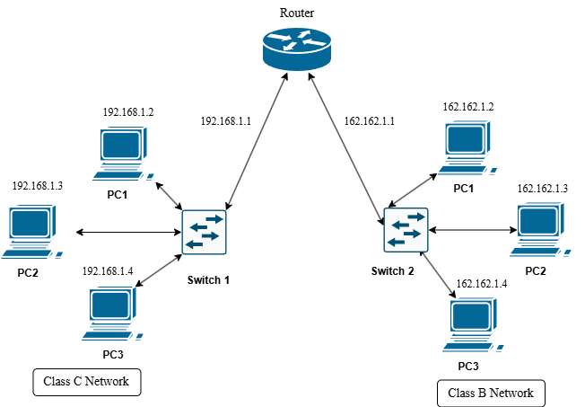

Procedure:
- Open Cisco Packet Tracer and place 1 router, 2 switches, and 6 PCs on the workspace.

- Connect PC1, PC2, and PC3 to Switch1 using copper straight-through ethernet cables. Connect the remaining PC4, PC5, and PC6 to Switch2 in the same way. Then connect Switch1 to one interface of the router (Fa0/0) and Switch2 to the other interface (Fa0/1).

- Assign static IP addresses to all PCs in their respective networks as follows:

Switch1 Network (192.168.1.0/24):
Device | IP Address | Default Gateway
PC1 | 192.168.1.2 | 192.168.1.1
PC2 | 192.168.1.3 | 192.168.1.1
PC3 | 192.168.1.4 | 192.168.1.1

Switch2 Network (162.162.1.0/24):
Device | IP Address | Default Gateway
PC4 | 162.162.1.2 | 162.162.1.1
PC5 | 162.162.1.3 | 162.162.1.1
PC6 | 162.162.1.4 | 162.162.1.1

Since the two groups of PCs belong to different networks, a default gateway is required for inter-network communication. The default gateway for each PC is the IP address of the router interface connected to its network.

- Configure the router interfaces via the CLI. Click on the router, open the CLI tab, and enter the following commands:
Router> enable
Router# configure terminal

Router(config)# interface FastEthernet0/0
Router(config-if)# ip address 192.168.1.1 255.255.255.0
Router(config-if)# no shutdown
Router(config-if)# exit

Router(config)# interface FastEthernet0/1
Router(config-if)# ip address 162.162.1.1 255.255.255.0
Router(config-if)# no shutdown
Router(config-if)# end

- To assign IP addresses to the PCs, click on each PC, go to Desktop → IP Configuration, select Static, and enter the IP address, subnet mask (255.255.255.0), and default gateway as listed in the table above.

- Verify connectivity by opening the Command Prompt on a PC in Switch1's network and pinging a PC in Switch2's network. For example:
ping 162.162.1.2

- Observe the ping replies. Successful replies confirm that the router is correctly forwarding packets between the two different networks.

Output:
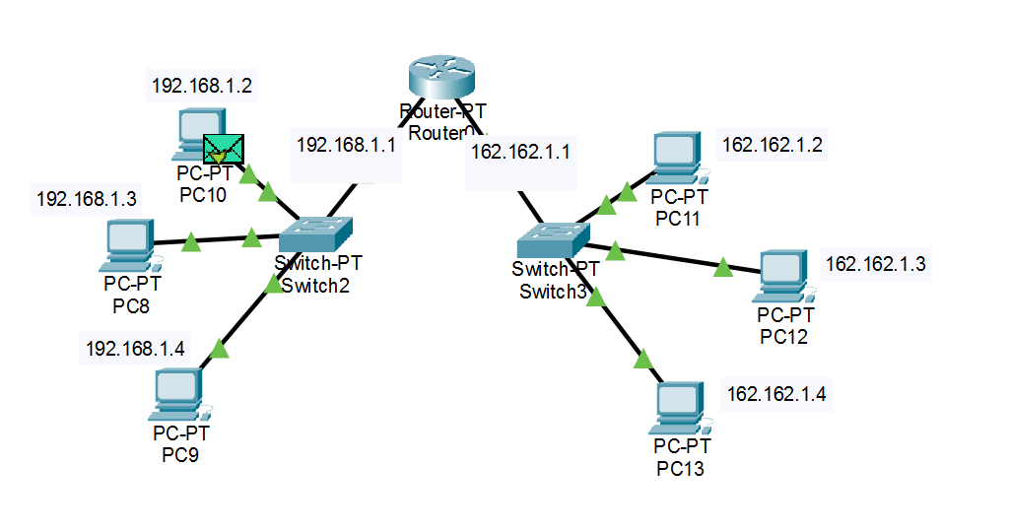

Jahangirnagar University
Institute of Information Technology
Savar, Dhaka-1342

Lab report - 04
IP Address Assign Using DHCP

Course: Computer Networks Lab
Course Code: ICT-3104

Submitted To
Jesmin Akhter, PhD
Professor, Institute of Information Technology
Submitted By
Md. Shaon Khan
ID: 1984 Batch: 52 Session: 2022–2023

Date of Submission
7 May 2026

Lab -4: IP Address Assign Using DHCP

Objective:
To understand how IP addresses are dynamically assigned to end devices using DHCP (Dynamic Host Configuration Protocol), and to observe the automatic IP configuration process in a simulated network environment.

Apparatus:
1. Cisco Packet Tracer
2. Router
3. Switches
4. Server (DHCP Server)
5. end devices (PCs)
6. Copper straight through ethernet wire

Network diagram:

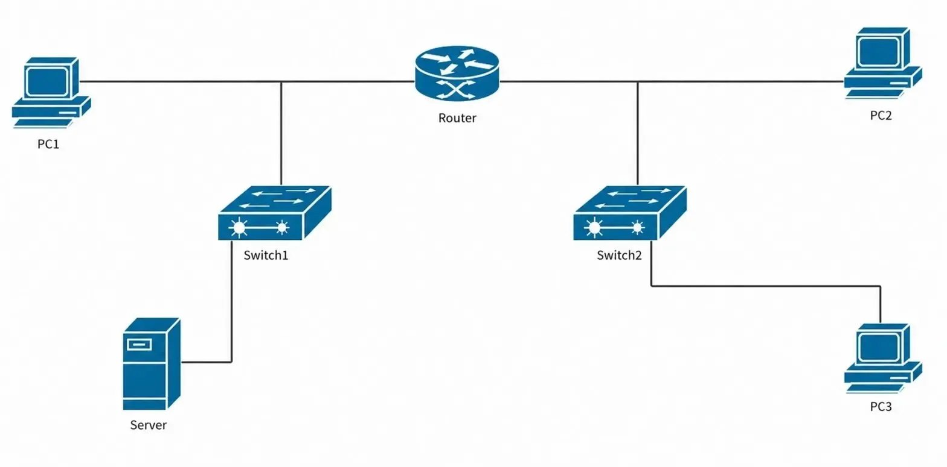

Procedure:
- Open Cisco Packet Tracer and build the network topology as shown in the network diagram. Place one Router (Router2), two Switches (Switch4 and Switch5), one Server (Server4), and five PCs (PC8, PC9, PC10, and two more) on the workspace.

- Connect all devices using copper straight-through ethernet cables as follows: PC8 (Fa0) to Switch4 (Fa1/1), Server4 (Fa0) to Switch4 (Fa2/1), Switch4 (Fa0/1) to Router2 (Fa0/0), Router2 (Fa1/0) to Switch5 (Fa0/1), PC9 (Fa0) to Switch5 (Fa1/1), PC10 (Fa0) to Switch5 (Fa2/1).

- Assign a static IP address to Server4. Click on Server4, go to Desktop > IP Configuration, and enter the following:
  - IP Address : 192.168.1.100
  - Subnet Mask : 255.255.255.0
  - Default GW : 192.168.1.1

- Configure the router interfaces with static IP addresses. Click on Router2, open the CLI tab, and enter the following commands:
  - Router> enable
  - Router# configure terminal
  - Router(config)# interface FastEthernet0/0
  - Router(config-if)# ip address 192.168.1.1 255.255.255.0
  - Router(config-if)# ip helper-address 192.168.1.100
  - Router(config-if)# no shutdown
  - Router(config-if)# exit
  - Router(config)# interface FastEthernet1/0
  - Router(config-if)# ip address 192.168.2.1 255.255.255.0
  - Router(config-if)# ip helper-address 192.168.1.100
  - Router(config-if)# no shutdown
  - Router(config-if)# end

- Configure the DHCP service on Server4. Click on Server4, go to Services > DHCP, and set up two address pools as follows:
  - Pool Name : Network1
  - Start IP : 192.168.1.2
  - Subnet Mask : 255.255.255.0
  - Default GW : 192.168.1.1

  - Pool Name : Network2
  - Start IP : 192.168.2.2
  - Subnet Mask : 255.255.255.0
  - Default GW : 192.168.2.1

- Enable DHCP service on the server by turning the service ON in the DHCP settings page. Click Add after entering each pool configuration.

- Set each PC’s IP configuration to DHCP mode. Click on each PC, go to Desktop > IP Configuration, and select DHCP. Each PC will automatically receive an IP address, subnet mask, and default gateway from the server. Verify that the assigned addresses match the expected ranges from the diagram (PC8: 192.168.1.2, PC9: 192.168.2.2, PC10: 192.168.2.3).

- Verify connectivity by opening a command prompt on any PC (Desktop > Command Prompt) and using the ping command to test communication between PCs on both networks. For example:
  - C:\> ping 192.168.2.2
  - C:\> ping 192.168.1.2

- Observe the successful ping replies confirming that DHCP has assigned correct IP addresses and the router is properly forwarding packets between the two networks through the centralized DHCP server.

Output:

